**The business goals**

To increase revenue of Wat Pha Som and persuade other people to support Wat Pha Som.

**The as-is system**

In old web system has features such as cart system, member system and look like a bit disorderly.The user can comment on any product that on the list.About the purchase system user can pick products to the cart then transaction through the bank transaction system.In member system can register by email address.

**The To-be system**

In our E-commerce site system focus on easy to use. Users that have a little experience can use our website immediately(don't need to learn more).Our web system can store data in the database such as order list, order history, user data(id, address, name) and link to the PAYPAL site for a payment system(user must have a PayPal account).Then payment history will store in our database.This web also provides admin to manage about USER, PRODUCT, ORDER LIST.In product page has amount of in stock product to show to the user.Member system in our system provides user to edit his account also have forgotten password feature to help the user recover their password.A member can view the status of order Ex.Shipping,wait for transaction,finished.

**The overall of requirement**

Our system provide guest can register to website member by filling information in register page.When guests become members they can log into the system by username & password and the member also edit his account such as username, password, address, email.Member can logout the system..Every user include guest can see the list of products then select a product for purchase(only member).For the purchasing system when user click on purchase button webpage will link to PayPal site for transcation then the user can view purchase history.For admin system admin can edit the user account such as username,password also delete user account and admin can add new product/add new lot/edit lot/edit product/view inventory report by input product name, price, amount of product,description.last thing admin can change status of order (shipping, finished,waiting,....).

Details in each requirement

**URS01: Guest can register to become a customer by filling information.**

System provide guest register to the system.guest must fill the information such as username, password, email,phone number,address then system validate format for each type of input.

**URS02: Member can login to the system by using username and password.**

System provide the user that already has the account then input the username&password into login page to access the system.

**URS03: Member can edit his own account information.**

System provide the user to edit their own account such as username,password, email,phone number,address and system shall store updated information.

**URS04: Member can view his own account information.**

System provide the user to view their account information such as username,password, email,phone number,address.

**URS05: Member can recover his own password.**

System provide the user to recover their own password by input their email address into recovery password page system shall send the email to the user email that system get forgot password request that contain URL to make change for password.After user change their password system shall store new password into database.

**URS06: Member can logout to the system.**

System provide the user to log out the system.

**URS07: Admin can edit member account information**

System provide the admin to edit the information of member account such as username,password, email,phone number,address.System shall update account information in database.

**URS08: Admin can delete member account.**

System provides admin to delete the member accounts the system shall delete account data from database.

**URS09: everybody can see list of products.**

System provide every user(include non-member) to see list of products that have on the website such as product name,price,amount of product.

**URS10: member can make order by select product on the product list.**

System provide member to make order by input amount of product the system will calculate total price of product that user selected.System shall store to the order list in database.

**URS11: member can make payment by using PayPal.**

After member select product from product list and click the purchase button.System will link the Paypal site to user for transaction.

**URS12: Member can view Ordering history.**

After member order the products .Member can view the ordering history that show order time, order status, total price and amount of product.

**URS13: Admin can add new product.**

System provide admin to add new product in inventory by input name of product,price,amount of product,description the system shall stored data into database.

**URS14: Admin can add new lot of product.**

Systen provide admin to add new lot of product by input expire date and amount of product then system shall stored into database.

**URS15: admin can edit lot of product.**

System provide admin to edit lot of product such as expire date,amount of product then system will update into database.

**URS16: Admin can delete lot of product.**

System provide admin to delete lot of product the system will delete lot of product from database.

**URS17: admin can edit product information.**

System provide admin to edit product information such as product name,price,amount of product,description the system will update into database.

**URS18: admin can delete product in inventory.**

System provide admin to delete product in inventory then system will delete product data from database.

**URS19: admin can view inventory report.**

System provide admin to view inventory report that show product id,name,price,amount of product,total price.

**URS20: admin can change status order.**

System provide admin to change status order from member order which are waiting for payment,paid,transferring,cancle and close.

**URS21: admin can view order.**

System provide admin to view order that admin can select order from the same day or same location.

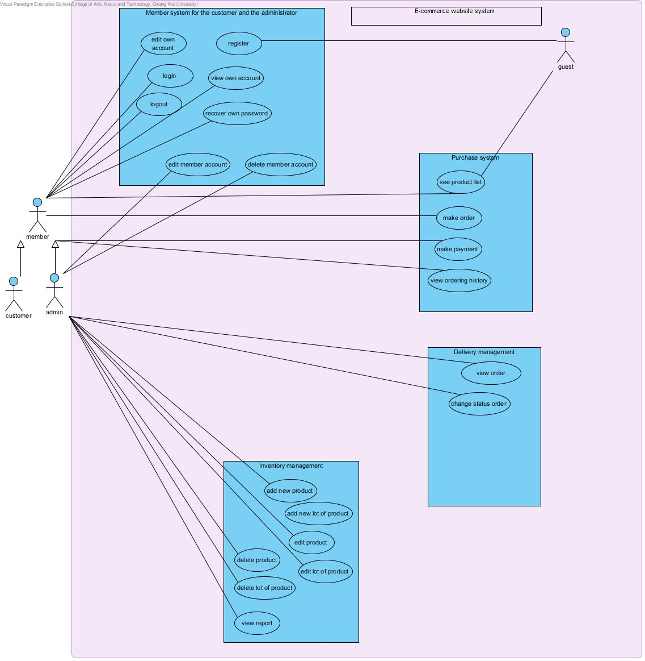

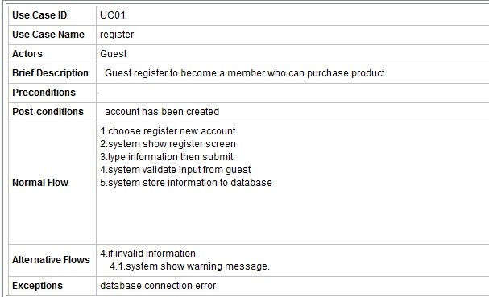

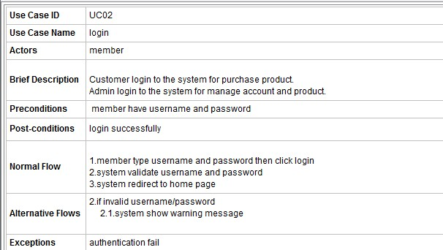

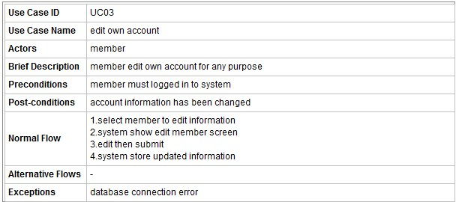

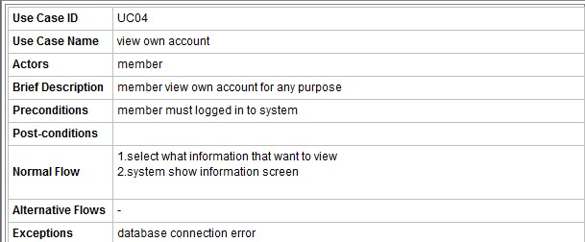

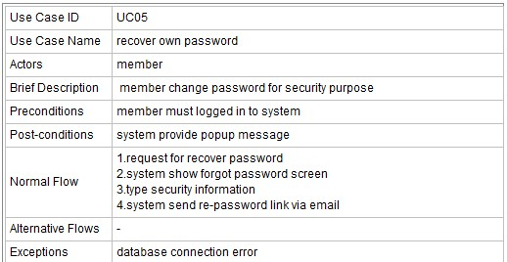

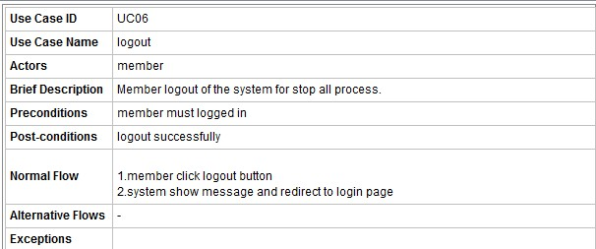

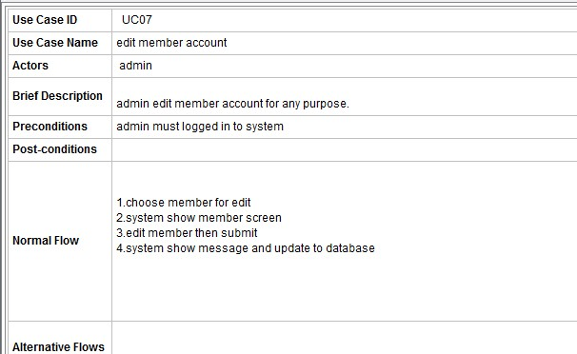

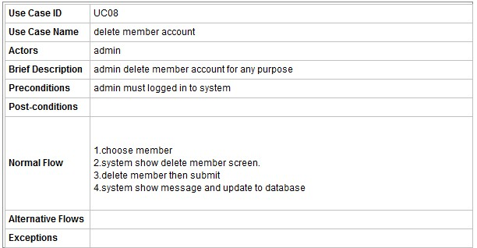

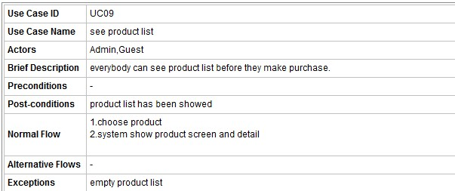

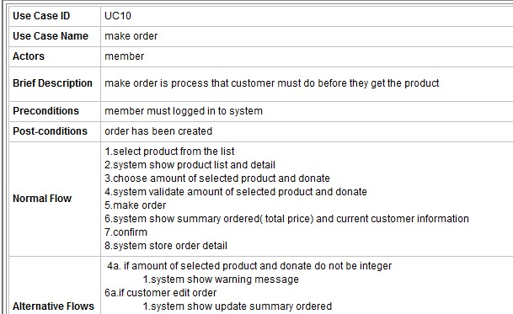

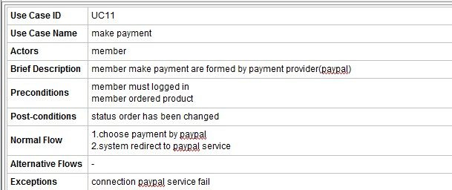

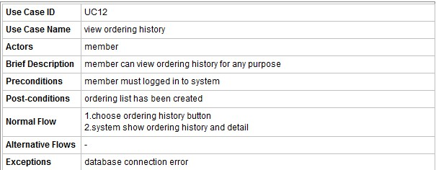

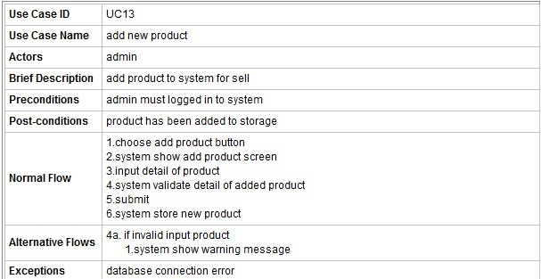

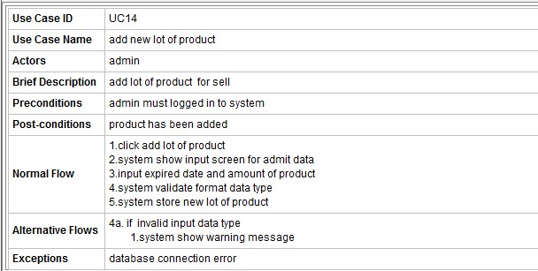

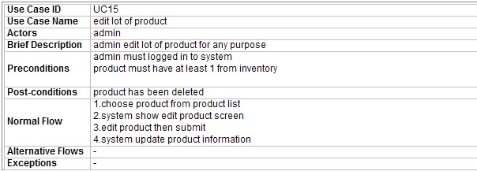

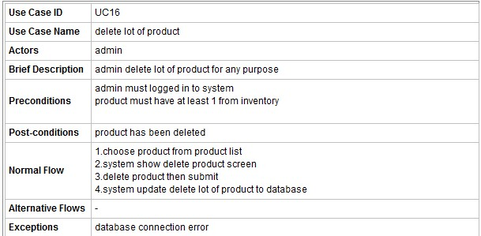

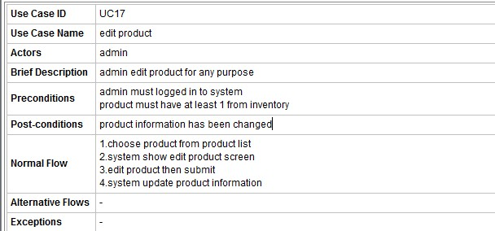

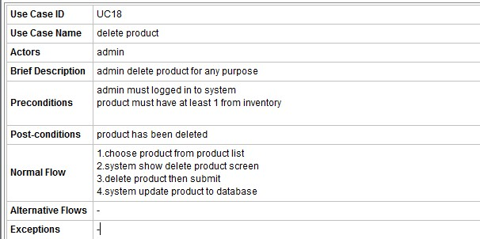

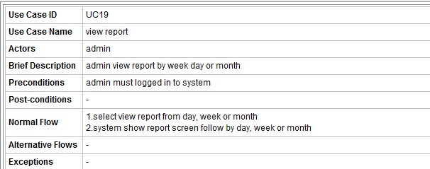

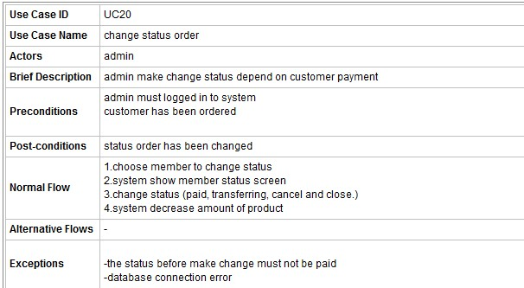

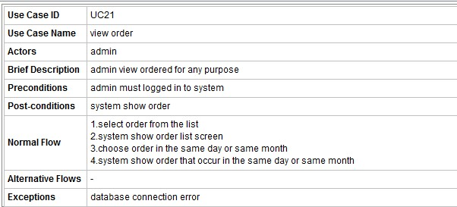

**Overall architecture design**

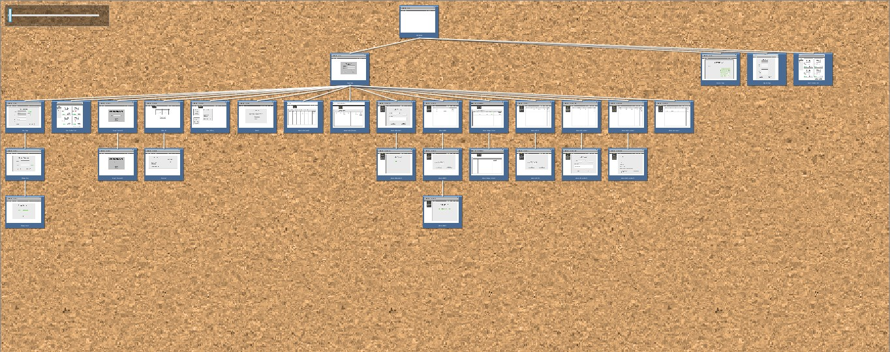

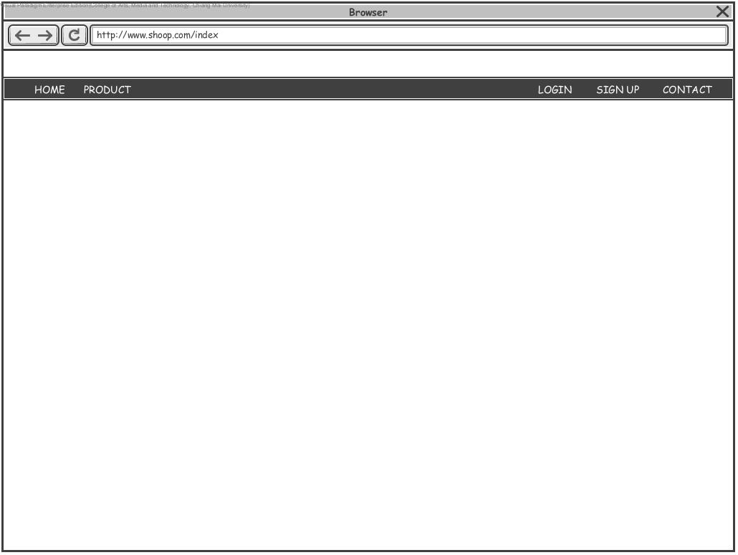

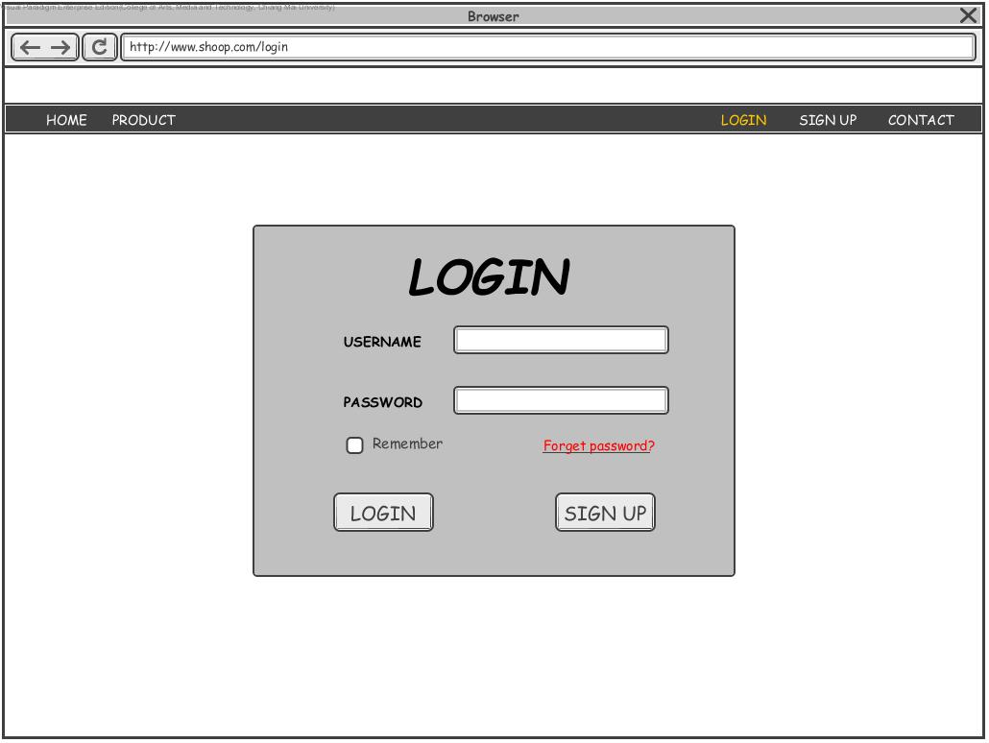

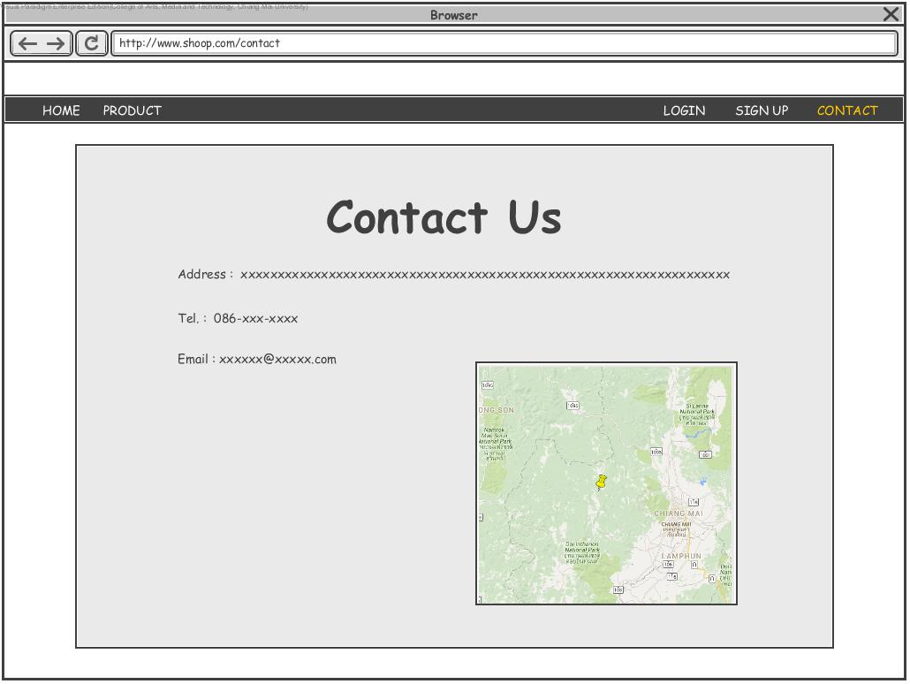

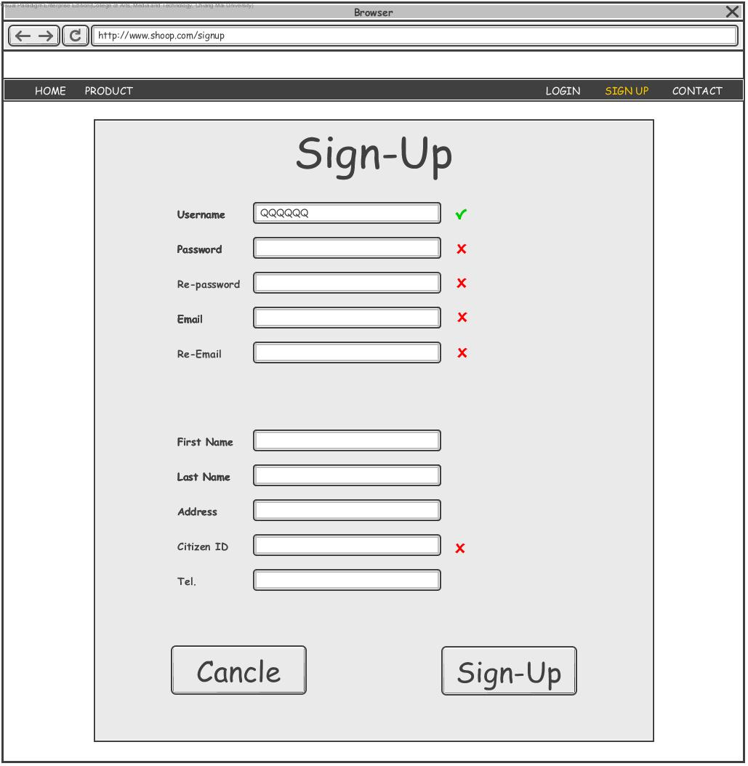

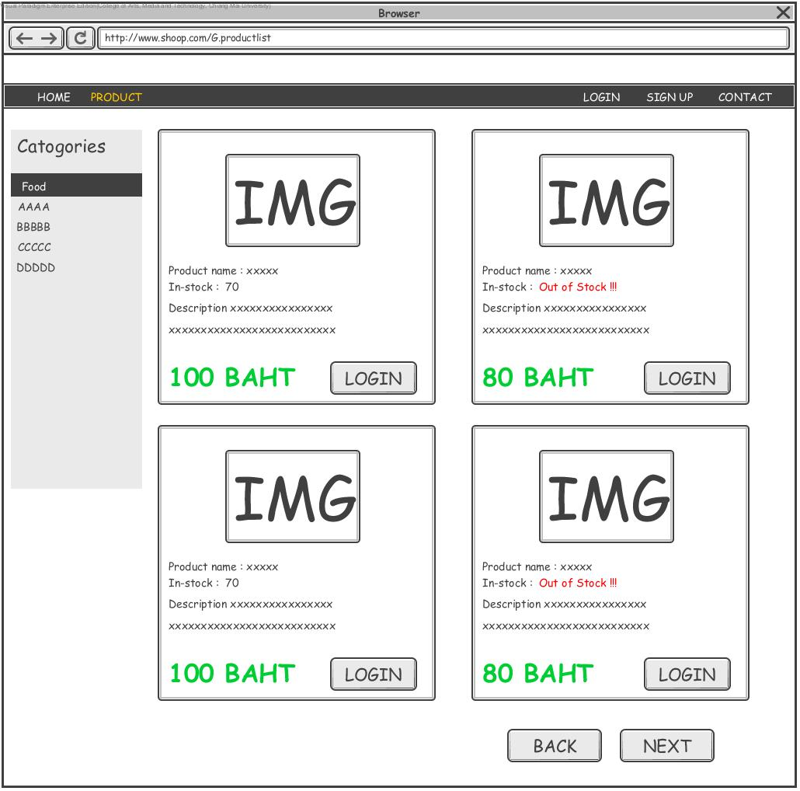

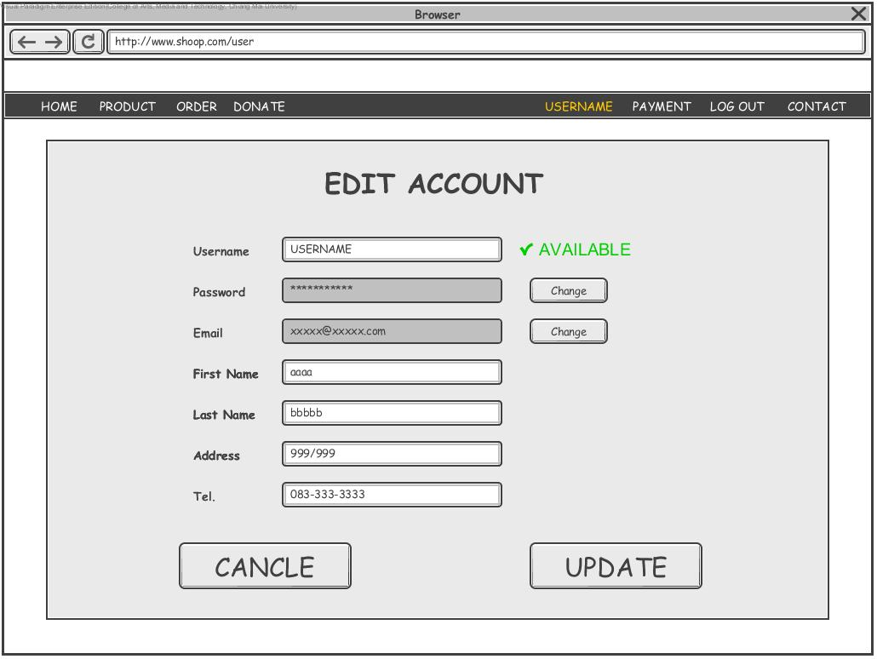

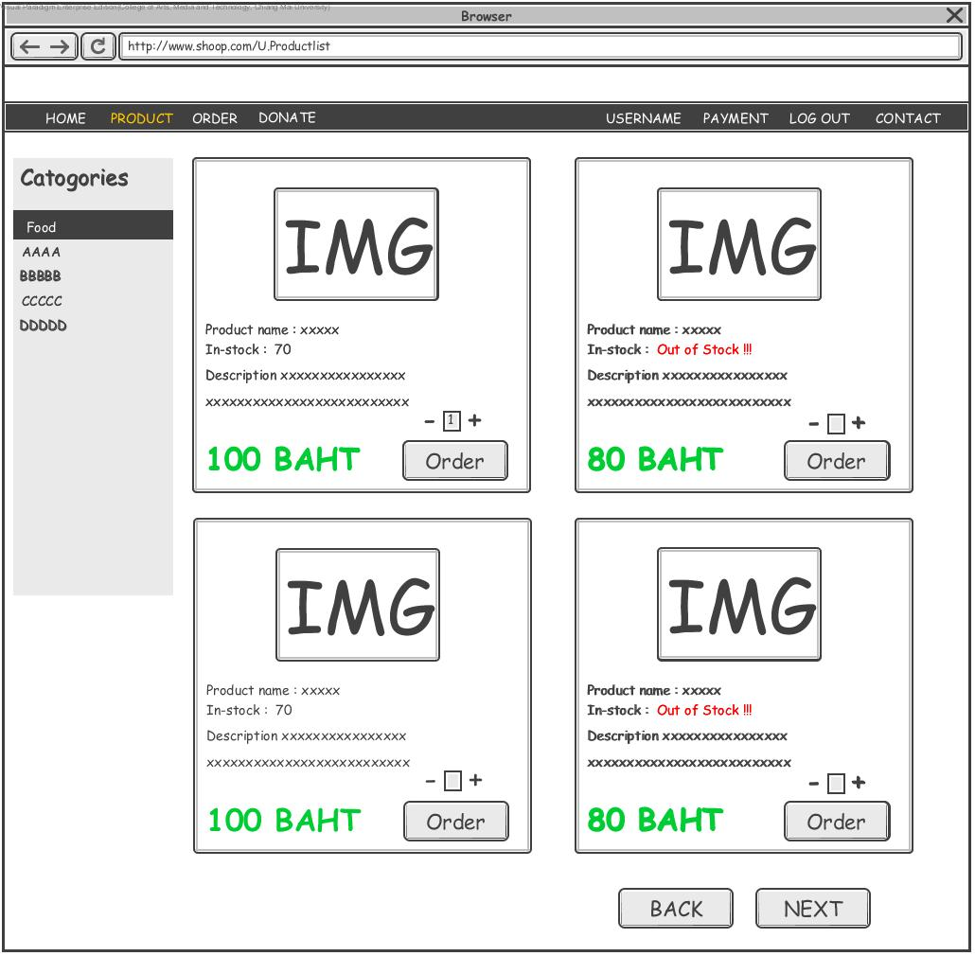

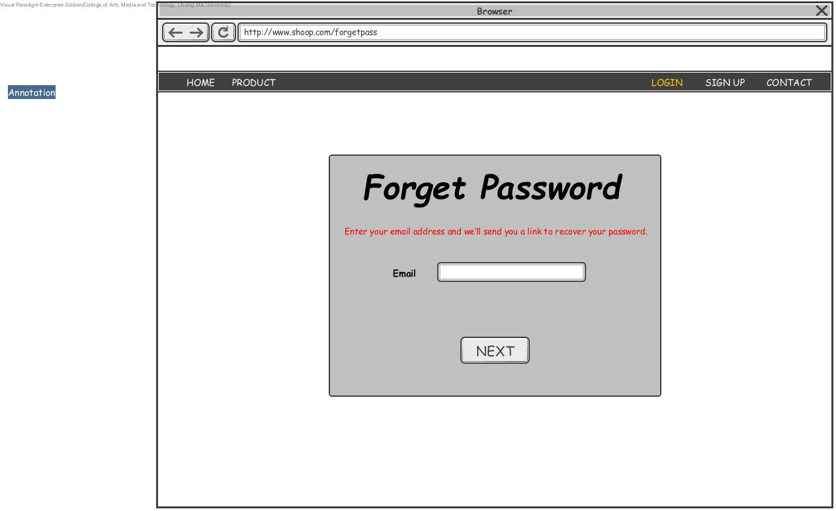

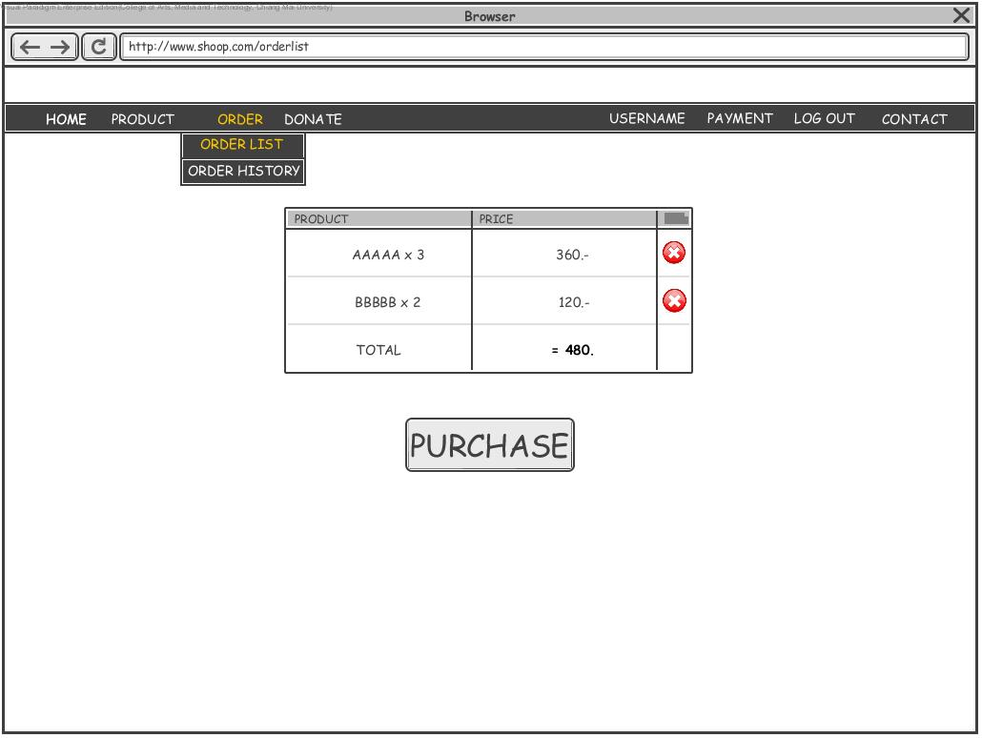

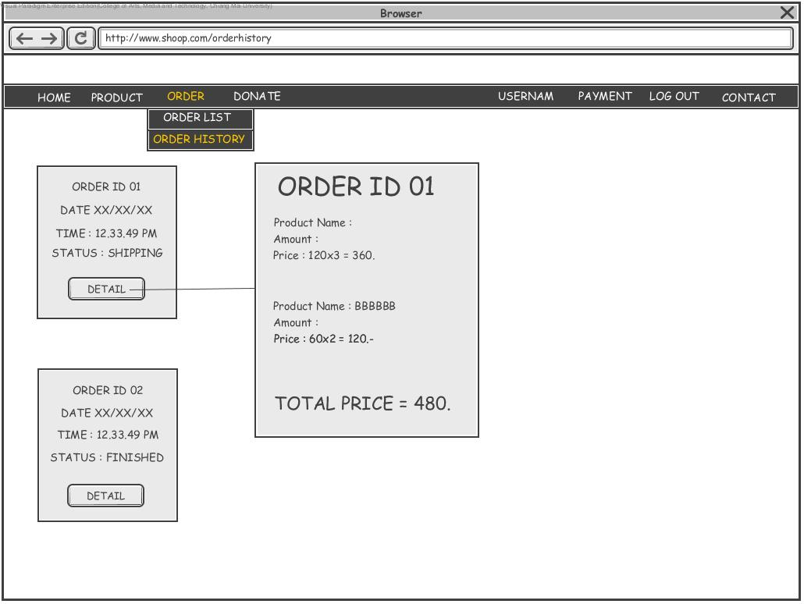

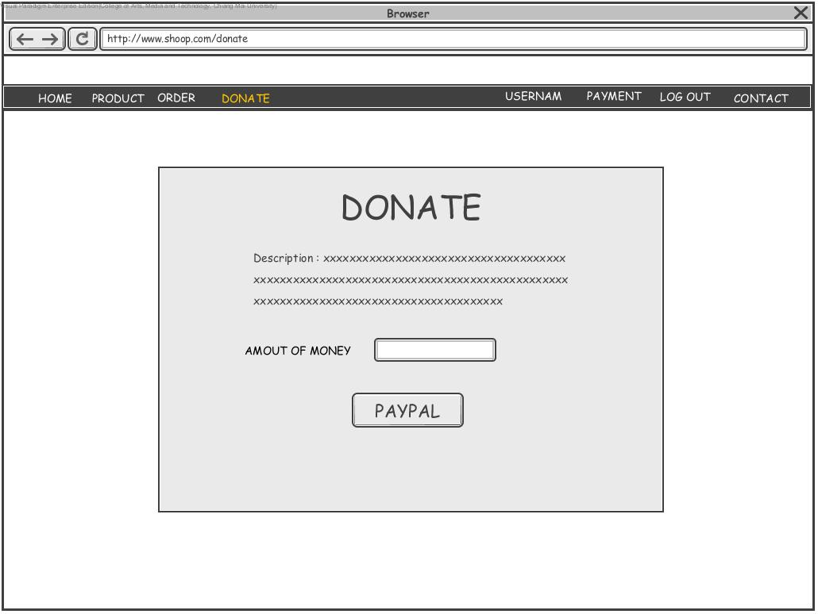

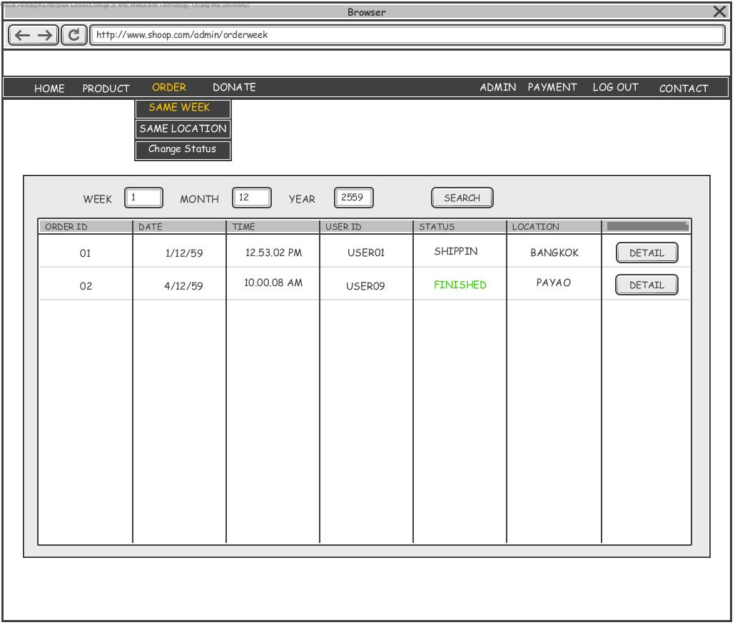

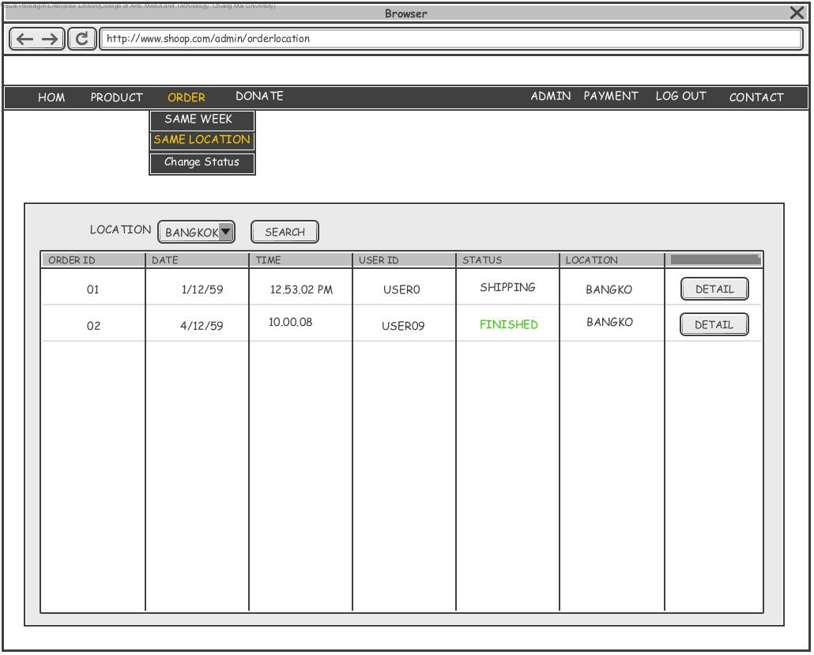

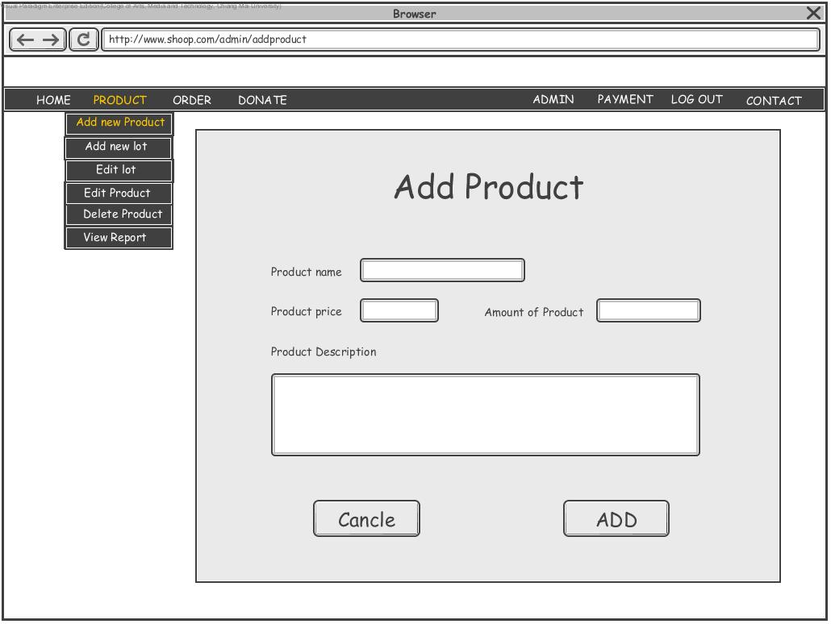

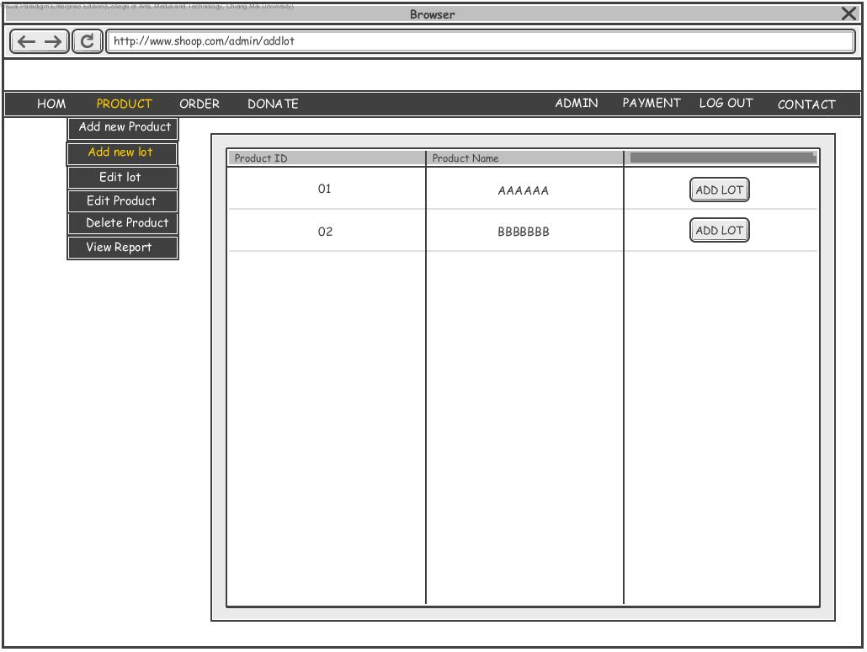

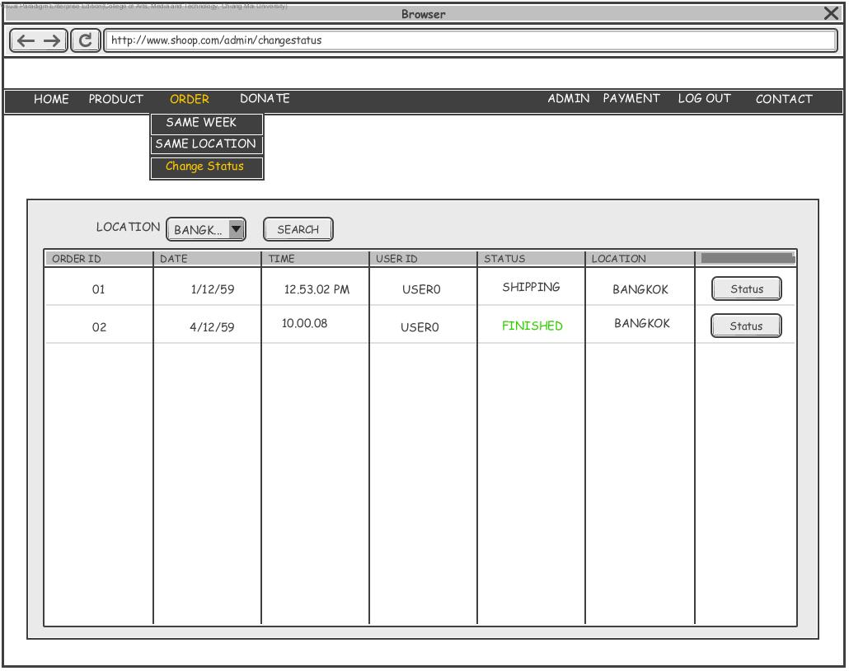

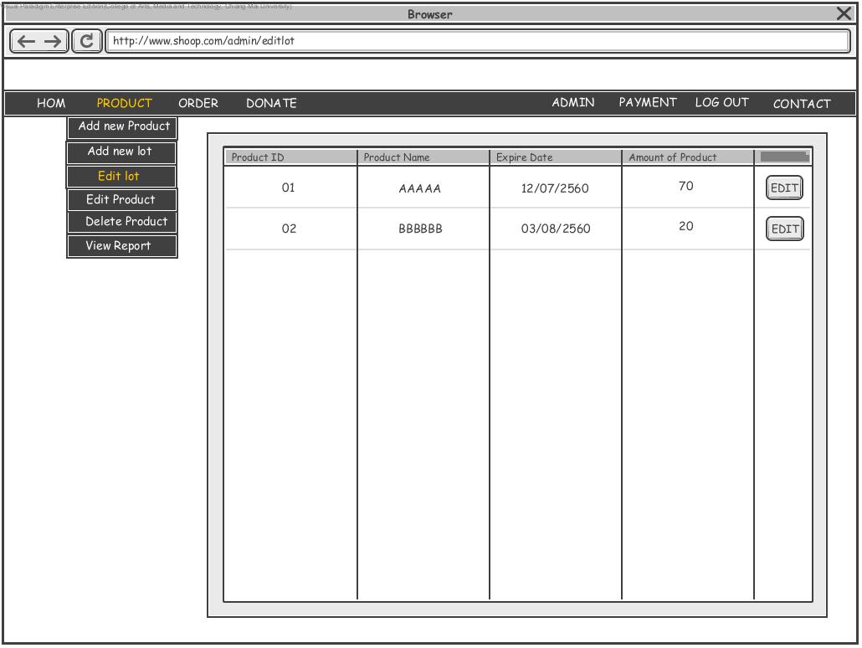

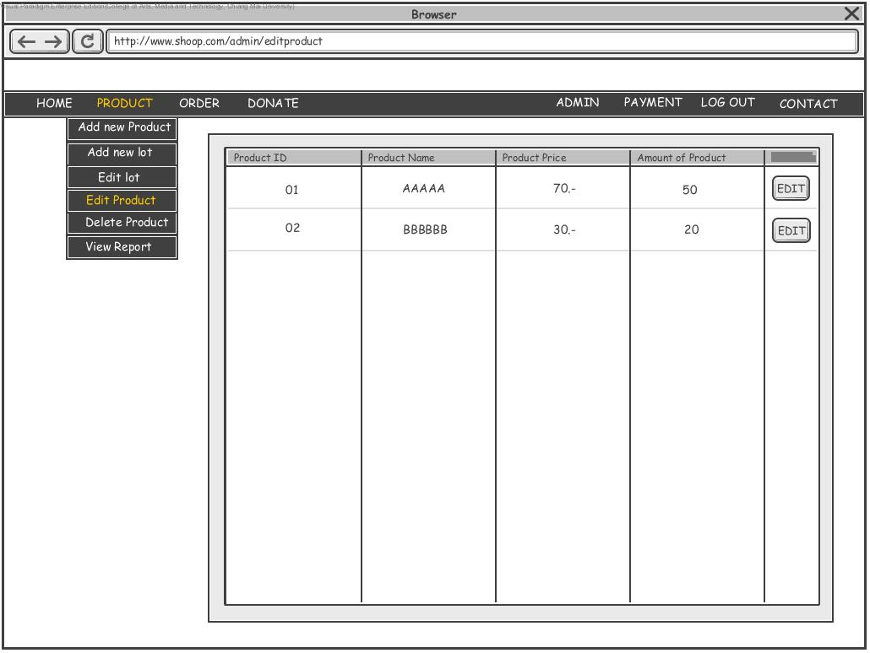

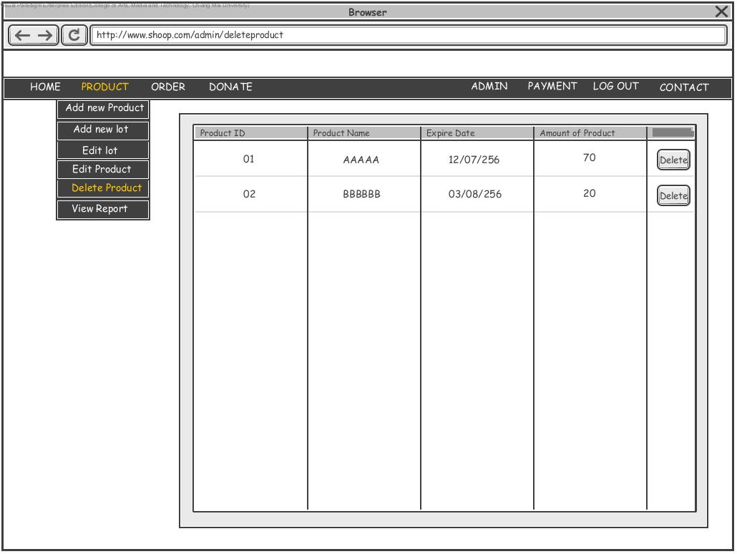

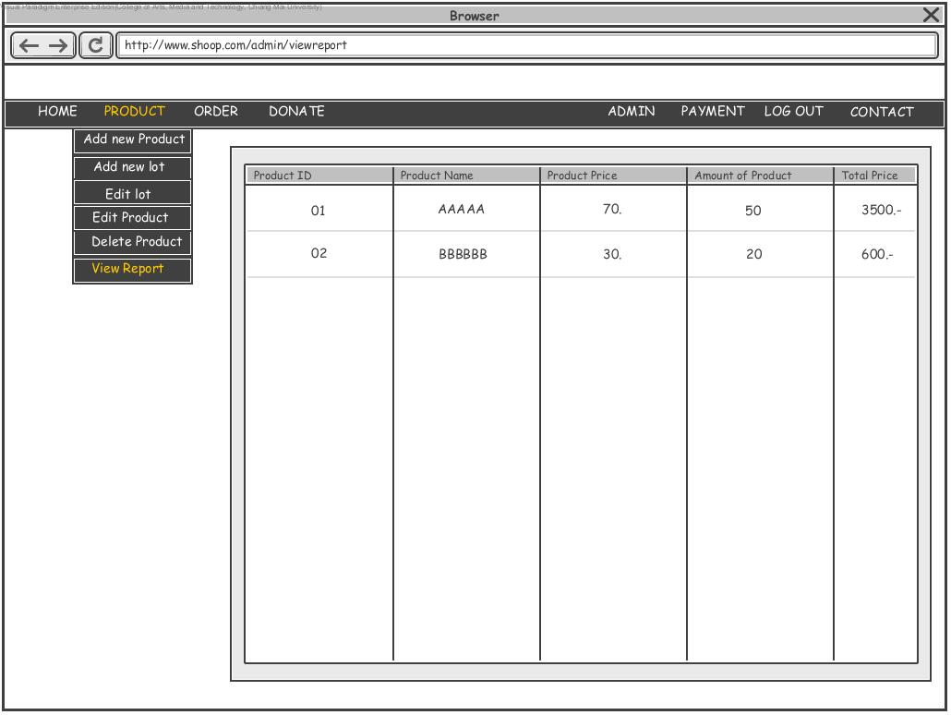

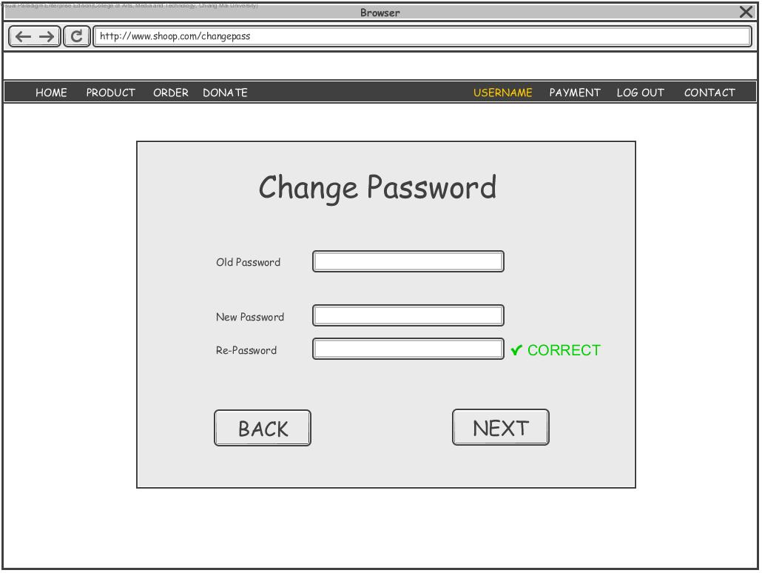

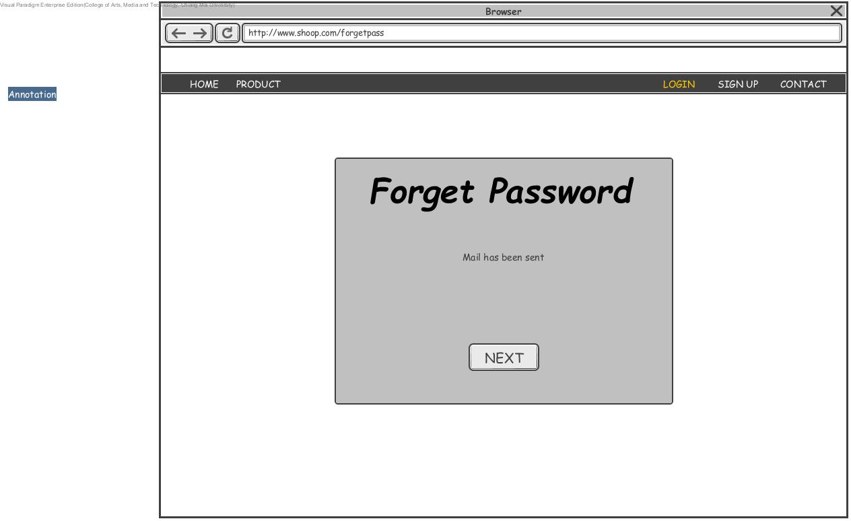

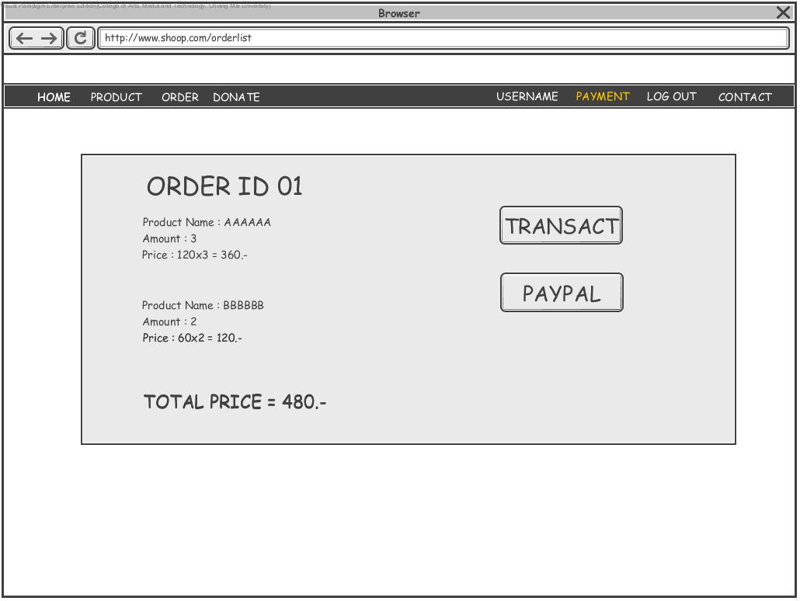

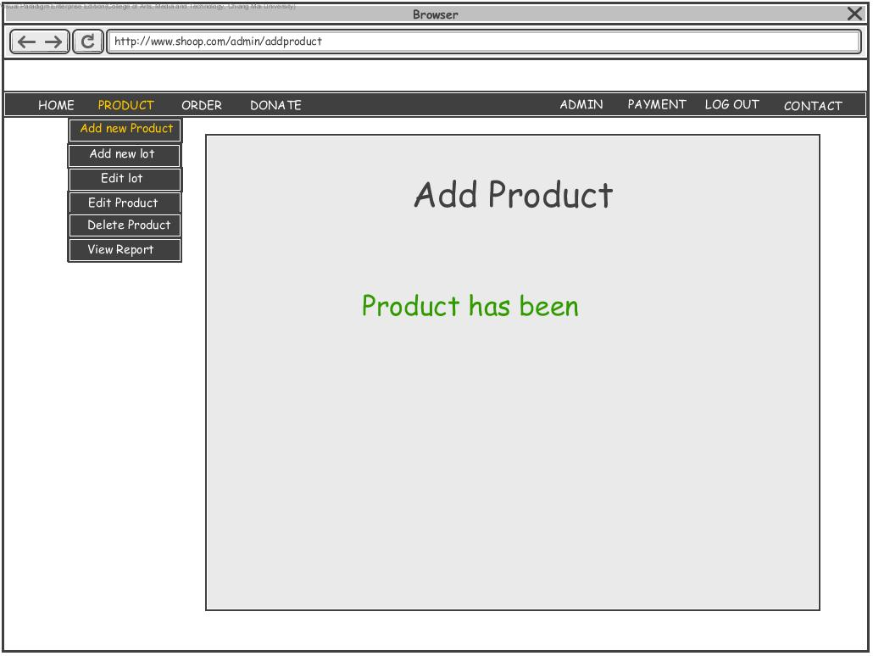

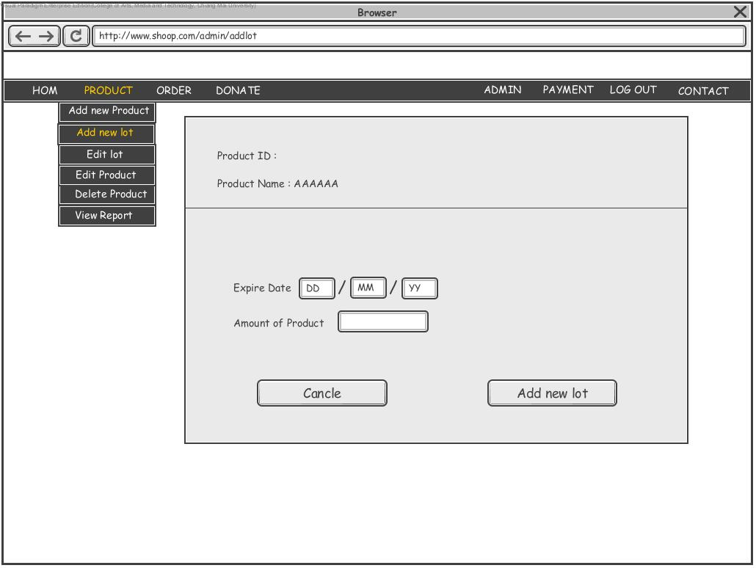

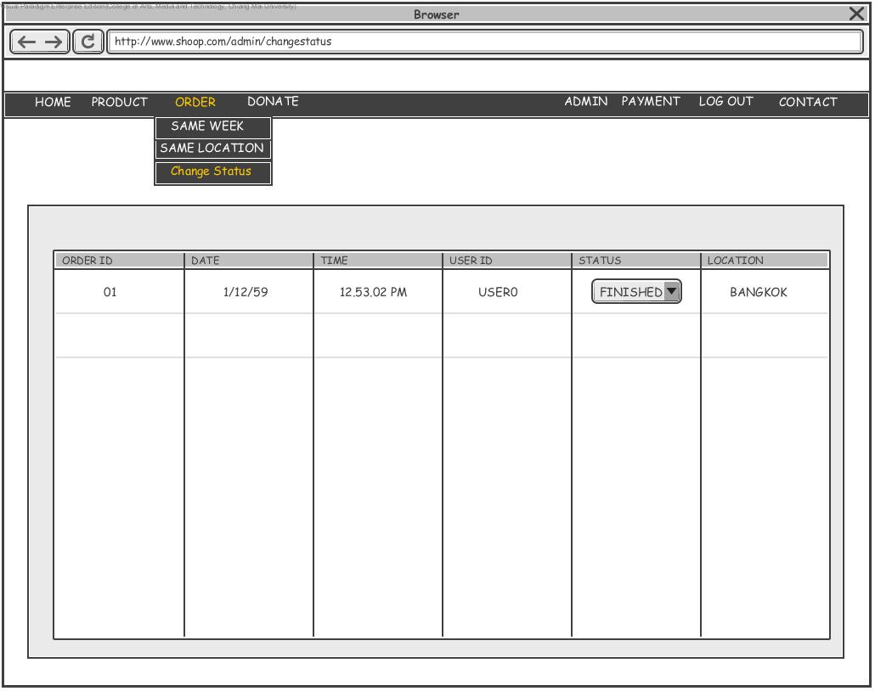

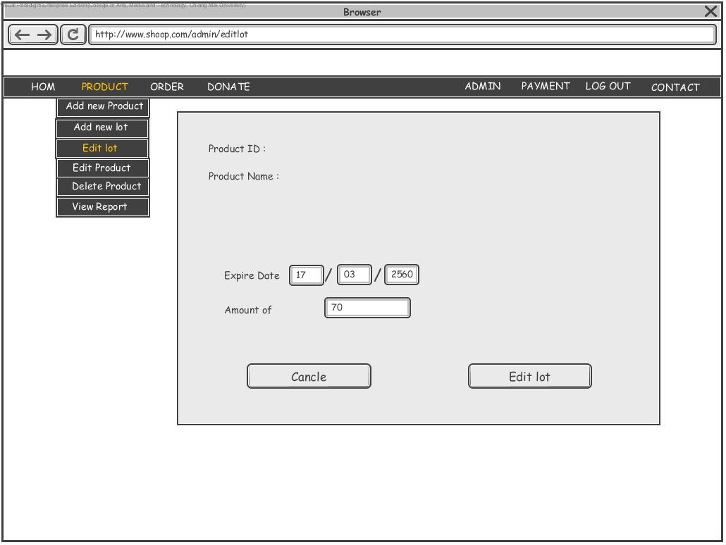

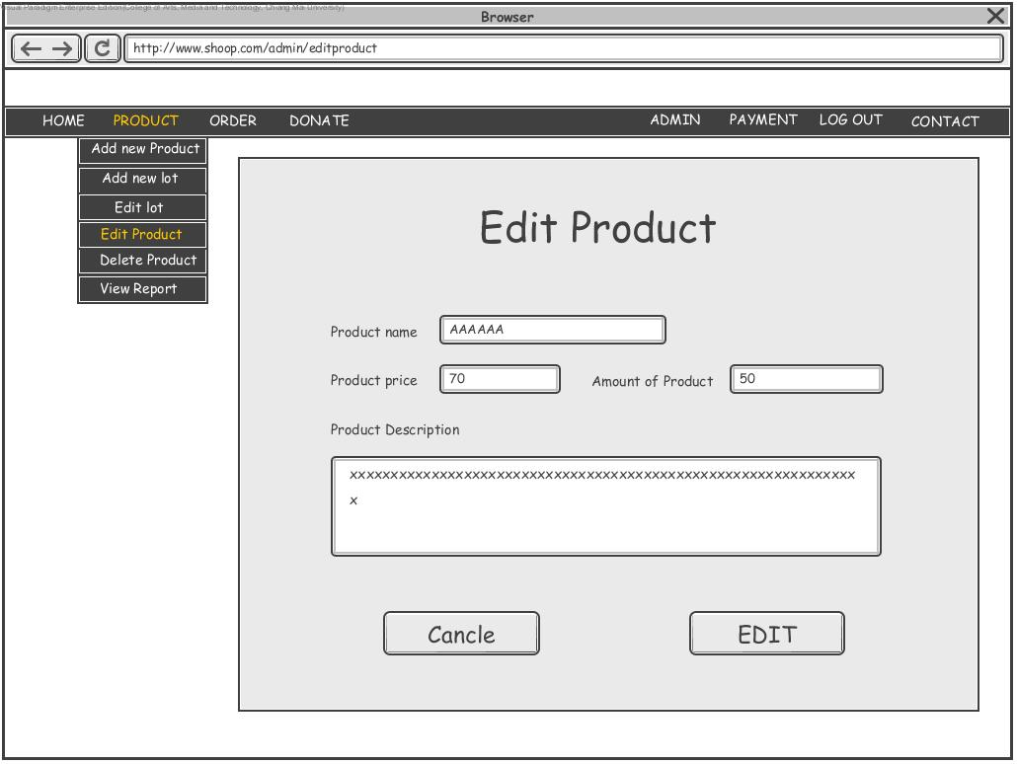

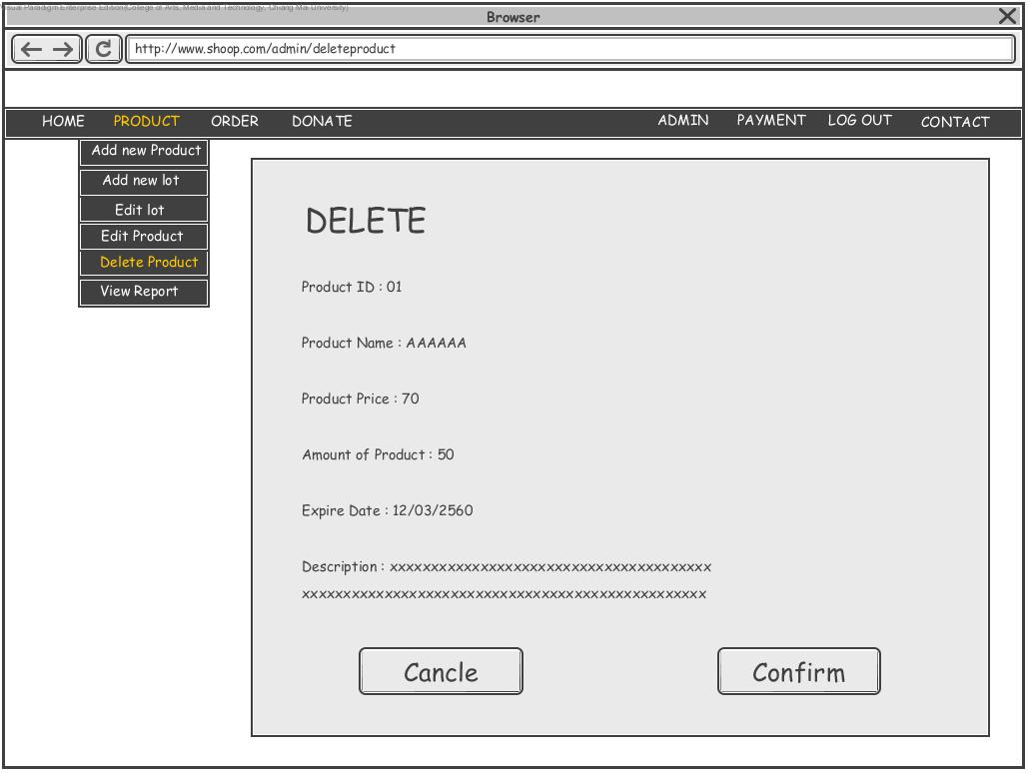

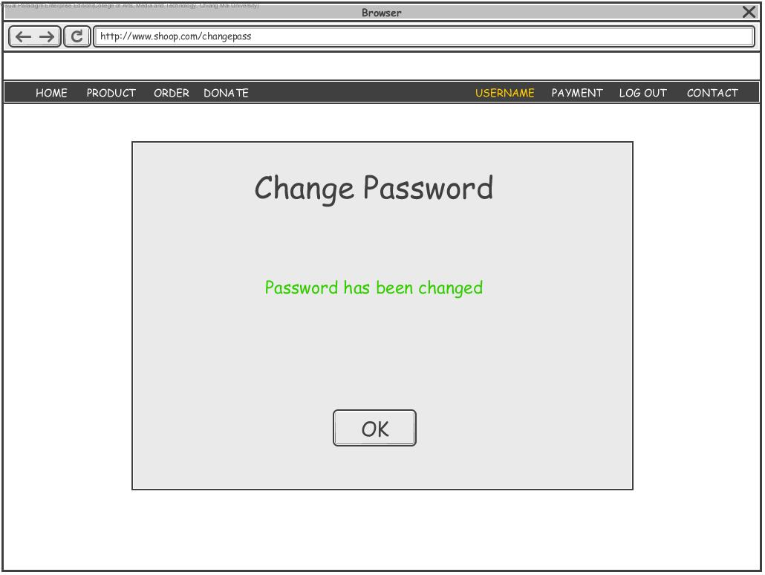

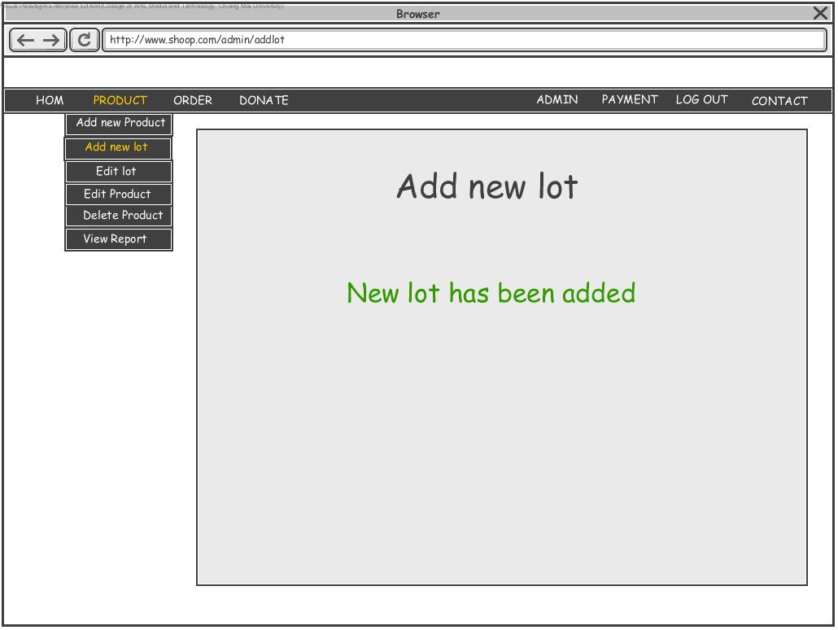

**The package design**

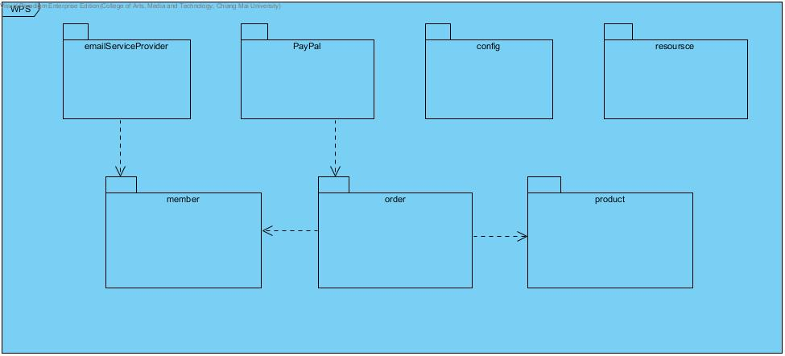

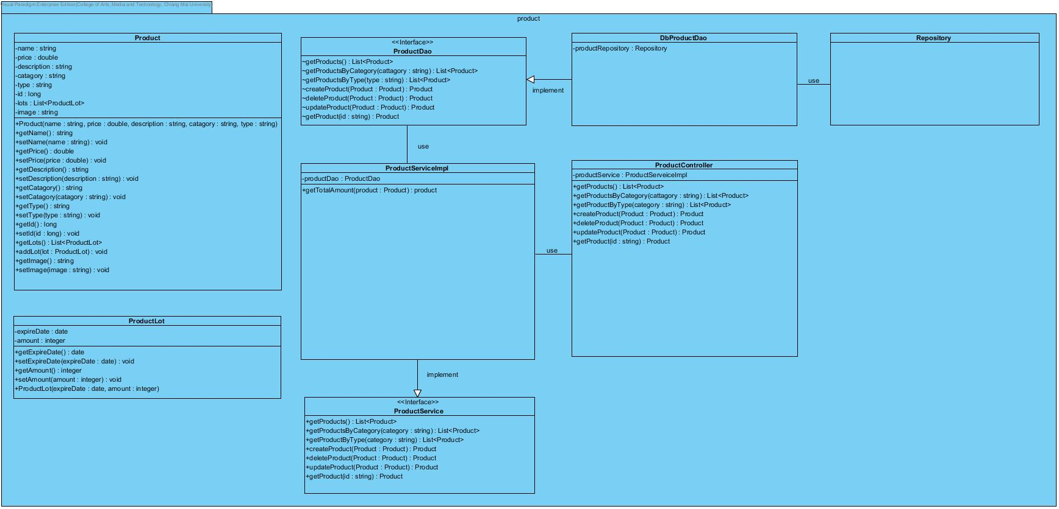

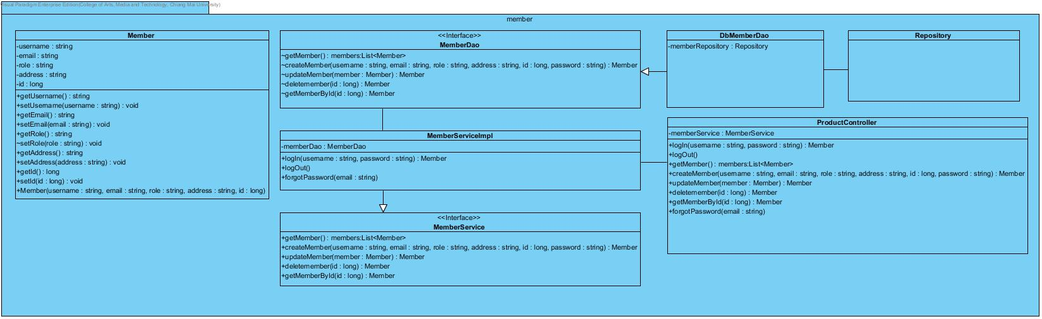

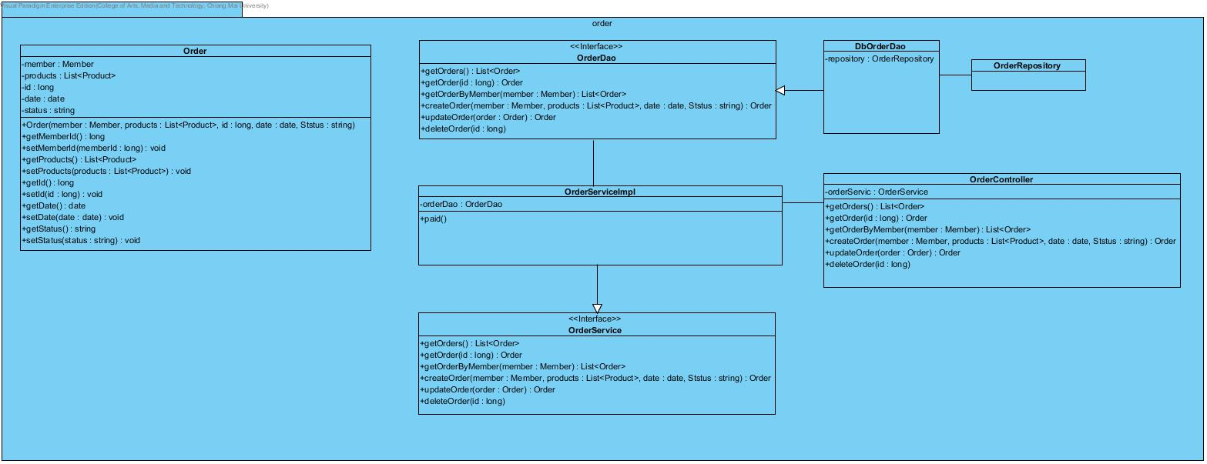

**Construction manual**

* *The problem is that our employer would like to get better e-commerce website than their original website.*
* *The opportunity is that we will get more experience and prepare for real work.*
* Ourgoal is: Complete a new e-commerce website follow by overall requirement
* We develop software by using IntelliJ(IDE) together with Spring framework also MVC pattern
* We create a repository by using GitHub (git provider) as well as collaboration tool to shred our source code
* JAVA is our main programming language
* Our server is locating on Microsoft Azure provided by our university
* **Data Dictionary**
* Guest: Every people which is access to this web application and haven’t register before.
* Customer: Account of people which is register to this web application.
* Member: Account of Customer and Admin.
* Admin: Account that have permission to do application data configuration activity and view the summary report.
* Member account information: Data that every account in the system must have; there are username, password, E-mail.

**Construction rules**

-In this section, we will summarize the construction methods of e-commerce website.

-This system describes relationships among product, member, and order.

-A fundamental problem in constructing this system is how to define relationships among them.

-Many kinds of relationships will arise among them in the life-cycle of software development. Developers need to communicate, collaborate, or coordinate with one another when they are performing different tasks in software development.

-We must commit the code when it's enough to make a difference in the usability of the system, but not so much that someone can't understand everything you did in a few minutes.

-The definition of done of our team not focus only in term of functionality but in terms of quality as well.

-The existing methods for constructing this system can be divided into a few categories:

-build it –test it –deploy it –support it.

-We additionally using mvc pattern to apply with this system, because of change.

-Mvc provide separate for change and we use Spring framework that answer this question

**URS-SRS**

**Member system for the customer and the administrator**

**URS01: Guest can register to become a customer by filling information.**

**SRS-01**: System shall provide user interface to user for input username, password, confirm password, E-mail, phone number and address.

**SRS-02**: System shall validate username that must be 6-20 characters, a-z, A-Z, 0-9, didn’t exist in the system and not empty.

**SRS-03**: System shall show the warning message “username must be 6-20 characters, a-z, A-Z, 0-9, and didn’t exist in the system” if input username don’t be 6-20 characters, a-z, A-Z, 0-9, or already have in the system.

**SRS-04**: System shall validate password that must be 6-20 characters, include letters, number and match with confirmed password and not empty.

**SRS-05**: System shall show the warning message “password must be 6-20 characters, a-z, A-Z, 0-9,” if input password don’t be 6-20 characters or include letters and number.

**SRS-06**: System shall validate E-mail that must be correct email format (RFC5322), exist in system and not empty.

**SRS-07**: System shall show the warning message “email already exist or email must be correct type” if input email don’t be correct format, already exist in system and not empty.

**SRS-08**: System shall validate phone number that must be 0-9, 10 digits number and start with 0.

**SRS-09**: System shall show the warning message “phone number must be 0-9 or number must be 10 digits or number must be start with 0” if input phone number don’t be 0-9 or 10 digits number or don’t start with 0.

**SRS-10**: System shall validate address which are address number, village No, sub-district, district, province and postal that must be not empty.

**SRS-11**: System shall show the error message “address must be not empty” if address don’t be input.

**SRS-12**: System shall store username, password, E-mail, phone number and address that passed validation to be a customer account.

**URS02: Member can login to the system by using username and password.**

**SRS-13**: System shall provide user interface for receive username and password form the user.

**SRS-14**: System shall make checking form input username and password for login to the system.

**SRS-15**: System shell show error message “invalid username or password” if username and password doesn’t correct.

**URS03: Member can edit his own account information.**

**SRS-16**: System shall provide user interface for edit Member account information which are username, password, E-mail, phone number and address.

**SRS-17**: System shall store updated information

**URS04: Member can view his own account information.**

**SRS-18**: System shall provide user interface that show username, email, phone number and address of that member account.

**URS05: Member can recover his own password.**

**SRS-19**: System shall provide user interface to send forgot password request to the system.

**SRS-20**: System shall send the email to the user email that system get forgot password request that contain URL to make change for password.

**SRS-21**: System shall update new password in database.

**URS06: Member can logout to the system.**

**SRS-22**: System shall provide user interface to request to logout form the system.

**SRS-23**: System shall logout for user.

**URS07: Admin can edit member account information**

**SRS-24**: System shall provide user interface for show list of member account.

**URS08: Admin can delete member account.**

**SRS-25**: System shall provide user interface for delete Member account information.

**SRS-26**: System can be delete a Member form database.

**Purchase system**

**URS09: everybody can see list of products.**

**SRS-27**: System shall provide user interface that show the list of product with detail which is product image, product name, product description and product price.

**URS10: member can make order by select product on the product list.**

**SRS-28**: System shall provide user interface for member to select product form the list of product and product detail which are product name, product price, product image and product description.

**SRS-29**: system shall provide user interface that show selected product.

**SRS-30**: System shall provide user interface for receive amount of selected product and donate.

**SRS-31**: System shall validate amount of selected product that must be integer.

**SRS-32**: System Shall Validate donate that must be double.

**SRS-33**: System shall provide total price form selected product.

**SRS-34**: System shall provide user interface for make order.

**SRS-35**: System shall provide order detail which are product selected list, member username, order tag, member address and phone number that user can edit before confirm.

**SRS-36**: System shall store order detail which are list of product, member id, time stamp, order status and update address and phone number.

**URS11: member can make payment by using PayPal.**

**SRS-37**: System shall provide user interface for make payment for each order that will use PayPal service.

**SRS-38**: System shall change order status to paid after user complete payment.

**URS12: Member can view Ordering history.**

**SRS-39**: System shall provide user interface that show order list of that member account with order detail are order time, order status, total price and amount of each product.

**SRS-40**: System shall show the product list of order history when user click.

**Inventory management**

**URS13: Admin can add new product.**

**SRS-41**: System shall provide user interface for receive input form admin account which are name of product, price of product, product description, category and type.

**SRS-42**: System shall validate product name that must be A-Z, a-z and 0-9 if not system shall alert warning message “product name must be A-Z, a-z and 0-9”.

**SRS-43**: System shall validate product price that must be double if not system shall alert warning message “product must be double”.

**SRS-44**: System shall store new product data if not system shall alert warning message.

**URS14: Admin can add new lot of product.**

**SRS-45**: System shall provide user interface for admit to input expired date and amount of product.

**SRS-46**: System shall validate expired date must be date format if not system shall alert warning message.

**SRS-47**: System shall validate amount of product that must be integer if not system shall alert warning message.

**SRS-48**: System shall store lot of product.

**URS15: admin can edit lot of product.**

**SRS-49**: System shall provide user interface for show lot of product.

**SRS-50**: System shall update lot of product form input expired date and amount of product.

**URS16: Admin can delete lot of product.**

**SRS-51**: System shall provide user interface for admin to delete a product.

**SRS-52**: System shall delete lot of product that selected form the system.

**URS17: admin can edit product information.**

**SRS-53**: System shall provide user interface for admin account to edit product information in product list.

**SRS-54**: System shall update product information.

**URS18: admin can delete product in inventory.**

**SRS-55**: System shall provide user interface for admin account for delete product.

**SRS-56**: System shall delete product and its lot.

**URS19: admin can view inventory report.**

**SRS-57**: System shall provide user interface for admin that show table of product id, product name, amount of product, product price, total price of each product.

**Delivery management**

**URS20: admin can change status order.**

**SRS-58**: System shall provide user interface for admin for change order status by select order status which are waiting for payment, paid, transferring, cancel and close.

**SRS-59**: System shall decrease amount of product in lot when order status change to paid.

**URS21: admin can view order.**

**SRS-60**: System shall provide user interface that show all of order in the list.

**SRS-61**: System shall can show all order that occur in the same day that select.

**SRS-62**: System shall can show all order that occur in the same month that select.

**Traceability Matrix**

|  |  |  |  |  |  |  |  |  |  |  |  |  |  |  |  |  |  |  |  |  |  |
| --- | --- | --- | --- | --- | --- | --- | --- | --- | --- | --- | --- | --- | --- | --- | --- | --- | --- | --- | --- | --- | --- |
| URS  SRS | 01 | 02 | 03 | 04 | 05 | 06 | 07 | 08 | 09 | 10 | 11 | 12 | 13 | 14 | 15 | 16 | 17 | 18 | 19 | 20 | 21 |
| 01 | X |  |  |  |  |  |  |  |  |  |  |  |  |  |  |  |  |  |  |  |  |
| 02 | X |  |  |  |  |  |  |  |  |  |  |  |  |  |  |  |  |  |  |  |  |
| 03 | X |  |  |  |  |  |  |  |  |  |  |  |  |  |  |  |  |  |  |  |  |
| 04 | X |  |  |  |  |  |  |  |  |  |  |  |  |  |  |  |  |  |  |  |  |
| 05 | X |  |  |  |  |  |  |  |  |  |  |  |  |  |  |  |  |  |  |  |  |
| 06 | X |  |  |  |  |  |  |  |  |  |  |  |  |  |  |  |  |  |  |  |  |
| 07 | X |  |  |  |  |  |  |  |  |  |  |  |  |  |  |  |  |  |  |  |  |
| 08 | X |  |  |  |  |  |  |  |  |  |  |  |  |  |  |  |  |  |  |  |  |
| 09 | X |  |  |  |  |  |  |  |  |  |  |  |  |  |  |  |  |  |  |  |  |
| 10 | X |  |  |  |  |  |  |  |  |  |  |  |  |  |  |  |  |  |  |  |  |
| 11 | X |  |  |  |  |  |  |  |  |  |  |  |  |  |  |  |  |  |  |  |  |
| 12 | X |  |  |  |  |  |  |  |  |  |  |  |  |  |  |  |  |  |  |  |  |
| 13 |  | X |  |  |  |  |  |  |  |  |  |  |  |  |  |  |  |  |  |  |  |
| 14 |  | X |  |  |  |  |  |  |  |  |  |  |  |  |  |  |  |  |  |  |  |
| 15 |  | X |  |  |  |  |  |  |  |  |  |  |  |  |  |  |  |  |  |  |  |
| 16 |  |  | X |  |  |  |  |  |  |  |  |  |  |  |  |  |  |  |  |  |  |
| 17 |  |  | X |  |  |  |  |  |  |  |  |  |  |  |  |  |  |  |  |  |  |
| 18 |  |  |  | X |  |  |  |  |  |  |  |  |  |  |  |  |  |  |  |  |  |
| 19 |  |  |  |  | X |  |  |  |  |  |  |  |  |  |  |  |  |  |  |  |  |
| 20 |  |  |  |  | X |  |  |  |  |  |  |  |  |  |  |  |  |  |  |  |  |
| 21 |  |  |  |  | X |  |  |  |  |  |  |  |  |  |  |  |  |  |  |  |  |
| 22 |  |  |  |  |  | X |  |  |  |  |  |  |  |  |  |  |  |  |  |  |  |
| 23 |  |  |  |  |  | X |  |  |  |  |  |  |  |  |  |  |  |  |  |  |  |
| 24 |  |  |  |  |  |  | X |  |  |  |  |  |  |  |  |  |  |  |  |  |  |
| 25 |  |  |  |  |  |  |  | X |  |  |  |  |  |  |  |  |  |  |  |  |  |
| 26 |  |  |  |  |  |  |  | X |  |  |  |  |  |  |  |  |  |  |  |  |  |
| 27 |  |  |  |  |  |  |  |  | X |  |  |  |  |  |  |  |  |  |  |  |  |
| 28 |  |  |  |  |  |  |  |  |  | X |  |  |  |  |  |  |  |  |  |  |  |
| 29 |  |  |  |  |  |  |  |  |  | X |  |  |  |  |  |  |  |  |  |  |  |
| 30 |  |  |  |  |  |  |  |  |  | X |  |  |  |  |  |  |  |  |  |  |  |
| 31 |  |  |  |  |  |  |  |  |  | X |  |  |  |  |  |  |  |  |  |  |  |
| 32 |  |  |  |  |  |  |  |  |  | X |  |  |  |  |  |  |  |  |  |  |  |
| 33 |  |  |  |  |  |  |  |  |  | X |  |  |  |  |  |  |  |  |  |  |  |
| 34 |  |  |  |  |  |  |  |  |  | X |  |  |  |  |  |  |  |  |  |  |  |
| 35 |  |  |  |  |  |  |  |  |  | X |  |  |  |  |  |  |  |  |  |  |  |
| 36 |  |  |  |  |  |  |  |  |  | X |  |  |  |  |  |  |  |  |  |  |  |
| 37 |  |  |  |  |  |  |  |  |  |  | X |  |  |  |  |  |  |  |  |  |  |
| 38 |  |  |  |  |  |  |  |  |  |  | X |  |  |  |  |  |  |  |  |  |  |
| 39 |  |  |  |  |  |  |  |  |  |  |  | X |  |  |  |  |  |  |  |  |  |
| 40 |  |  |  |  |  |  |  |  |  |  |  | X |  |  |  |  |  |  |  |  |  |
| 41 |  |  |  |  |  |  |  |  |  |  |  |  | X |  |  |  |  |  |  |  |  |
| 42 |  |  |  |  |  |  |  |  |  |  |  |  | X |  |  |  |  |  |  |  |  |
| 43 |  |  |  |  |  |  |  |  |  |  |  |  | X |  |  |  |  |  |  |  |  |
| 44 |  |  |  |  |  |  |  |  |  |  |  |  | X |  |  |  |  |  |  |  |  |
| 45 |  |  |  |  |  |  |  |  |  |  |  |  |  | X |  |  |  |  |  |  |  |
| 46 |  |  |  |  |  |  |  |  |  |  |  |  |  | X |  |  |  |  |  |  |  |
| 47 |  |  |  |  |  |  |  |  |  |  |  |  |  | X |  |  |  |  |  |  |  |
| 48 |  |  |  |  |  |  |  |  |  |  |  |  |  | X |  |  |  |  |  |  |  |
| 49 |  |  |  |  |  |  |  |  |  |  |  |  |  |  | X |  |  |  |  |  |  |
| 50 |  |  |  |  |  |  |  |  |  |  |  |  |  |  | X |  |  |  |  |  |  |
| 51 |  |  |  |  |  |  |  |  |  |  |  |  |  |  |  | X |  |  |  |  |  |
| 52 |  |  |  |  |  |  |  |  |  |  |  |  |  |  |  | X |  |  |  |  |  |
| 53 |  |  |  |  |  |  |  |  |  |  |  |  |  |  |  |  | X |  |  |  |  |
| 54 |  |  |  |  |  |  |  |  |  |  |  |  |  |  |  |  | X |  |  |  |  |
| 55 |  |  |  |  |  |  |  |  |  |  |  |  |  |  |  |  |  | X |  |  |  |
| 56 |  |  |  |  |  |  |  |  |  |  |  |  |  |  |  |  |  | X |  |  |  |
| 57 |  |  |  |  |  |  |  |  |  |  |  |  |  |  |  |  |  |  | X |  |  |
| 58 |  |  |  |  |  |  |  |  |  |  |  |  |  |  |  |  |  |  |  | X |  |
| 59 |  |  |  |  |  |  |  |  |  |  |  |  |  |  |  |  |  |  |  | X |  |
| 60 |  |  |  |  |  |  |  |  |  |  |  |  |  |  |  |  |  |  |  |  | X |
| 61 |  |  |  |  |  |  |  |  |  |  |  |  |  |  |  |  |  |  |  |  | X |
| 62 |  |  |  |  |  |  |  |  |  |  |  |  |  |  |  |  |  |  |  |  | X |

**Tools used****Github** is a web-based Git repository hosting service. It offers all of the distributed revision control and source code management (SCM) functionality of Git as well as adding its own features. Unlike Git, which is strictly a command-line tool, GitHub provides a Web-based graphical interface and desktop as well as mobile integration. It also provides access control and several collaboration features such as bug tracking, feature requests, task management, and wikis for every project.

GitHub offers both plans for private repositories and free accounts, which are usually used to host open-source software projects. As of February 2016, GitHub reports having over 12 million users and over 31 million repositories, making it the largest host of source code in the world.

The trademark mascot of GitHub is Octocat, an anthropomorphized cat with octopus limbs, done in a manga style.



**Visual Paradigm** features all the UML diagrams and ERD tools essentially in system and database design. Innovative modeling tools like Resource Catalog, Transitor and Nicknamer makes system modeling easy and cost-effective. Doc. Composer lets you produce detailed design specification ready to use in discussion with just a few clicks. Take a deeper look at Visual Paradigm, and you'll know why we're your right choice.



**Java** is a general-purpose computer programming language that is concurrent, class-based, object-oriented,and specifically designed to have as few implementation dependencies as possible. It is intended to let application developers "write once, run anywhere" (WORA), meaning that compiled Java code can run on all platforms that support Java without the need for recompilation. Java applications are typically compiled to bytecode that can run on any Java virtual machine (JVM) regardless of computer architecture. As of 2016, Java is one of the most popular programming languages in use,particularly for client-server web applications, with a reported 9 million developers.[citation needed] Java was originally developed by James Gosling at Sun Microsystems (which has since been acquired by Oracle Corporation) and released in 1995 as a core component of Sun Microsystems' Java platform. The language derives much of its syntax from C and C++, but it has fewer low-level facilities than either of them.

The original and reference implementation Java compilers, virtual machines, and class libraries were originally released by Sun under proprietary licences. As of May 2007, in compliance with the specifications of the Java Community Process, Sun relicensed most of its Java technologies under the GNU General Public License. Others have also developed alternative implementations of these Sun technologies, such as the GNU Compiler for Java (bytecode compiler), GNU Classpath (standard libraries), and IcedTea-Web (browser plugin for applets).

The latest version is Java 8, which is the only version currently supported for free by Oracle, although earlier versions are supported both by Oracle and other companies on a commercial basis.



**The Spring Framework** is an application framework and inversion of control container for the Java platform. The framework's core features can be used by any Java application, but there are extensions for building web applications on top of the Java EE platform. Although the framework does not impose any specific programming model, it has become popular in the Java community as an alternative to, replacement for, or even addition to the Enterprise JavaBeans (EJB) model. The Spring Framework is open source.



**IntelliJ IDEA** is a Java integrated development environment (IDE) for developing computer software. It is developed by JetBrains (formerly known as IntelliJ), and is available as an Apache 2 Licensed community edition, and in a proprietary commercial edition. Both can be used for commercial development.



**MySQL** is an open-source relational database management system (RDBMS); in July 2013, it was the world's second most widely used RDBMS, and the most widely used open-source client–server model RDBMS. It is named after co-founder Michael Widenius's daughter, My.The SQL abbreviation stands for Structured Query Language. The MySQL development project has made its source code available under the terms of the GNU General Public License, as well as under a variety of proprietary agreements. MySQL was owned and sponsored by a single for-profit firm, the Swedish company MySQL AB, now owned by Oracle Corporation. For proprietary use, several paid editions are available, and offer additional functionality.

MySQL is a popular choice of database for use in web applications, and is a central component of the widely used LAMP open-source web application software stack (and other "AMP" stacks). LAMP is an acronym for "Linux, Apache, MySQL, Perl/PHP/Python". Free-software open-source projects that require a full-featured database management system often use MySQL. Applications that use the MySQL database include: TYPO3, MODx, Joomla, WordPress, phpBB, MyBB, Drupal and other software. MySQL is also used in many high-profile, large-scale websites, including Google (though not for searches), Facebook,Twitter,Flickr, and YouTube.



**MongoDB** (from humongous) is a cross-platform document-oriented database. Classified as a NoSQL database, MongoDB eschews the traditional table-based relational database structure in favor of JSON-like documents with dynamic schemas (MongoDB calls the format BSON), making the integration of data in certain types of applications easier and faster. MongoDB is developed by MongoDB Inc. and is published as free and open-source software under a combination of the GNU Affero General Public License and the Apache License. As of July 2015, MongoDB is the fourth most popular type of database management system, and the most popular for document stores.

Reference : [https://en.wikipedia.org](https://en.wikipedia.org/)